# Testing the shopping Program

For validating the program, a few inputs are used to check whether it responds as it is meant to or not.

For such an activity, **3** different test cases are used to verify the functionality of the system.

## Test 1: choosing product 3.

Output should be “You have chosen product 3, Balloons (12 pack)” and price display along with spent money so far = $1.

As can be seen on the screenshot below, results are as expected.

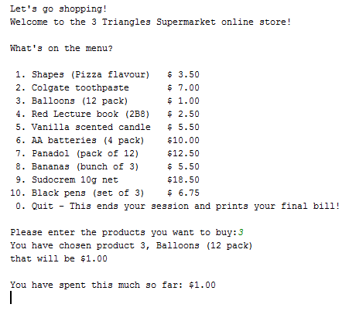

Figure : choose product 3

## Test 2: Selecting 1 of each product, and then quitting shopping program.

The result should display 1 of each item at the end of the program, along with a total cost of $72.75

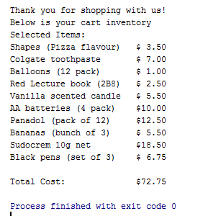

Figure :choosing 1 of each product:

## Test 3: Entering a character instead of a digit, then inputting 11 instead of 1.

In both cases, the screen should mention that the user has inputted a wrong value through a message.

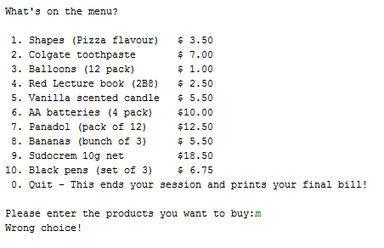

Figure : inputting a character

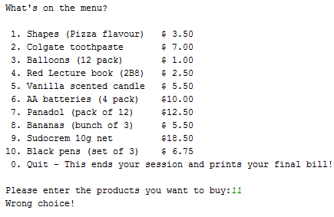

Figure : inputting an out of bound value

Through these scenarios it can be determined that the program works as it was intended to.

# Testing enhanced program

The enhanced program is an extension of the basic program requirements, with some added features such as clearing cart and payment of products. A few test cases will be used to ensure the capabilities of the program.

## Test 1: Selecting first 5 items & quit selection. From there clear cart.

Result of such an operation should have cart cleared completely.

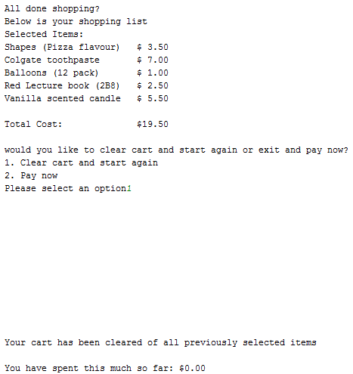

Figure : clearing cart

## Test 2: Select first 5 items and pay now.

Program should check whether items are paid for and display items and total cost.

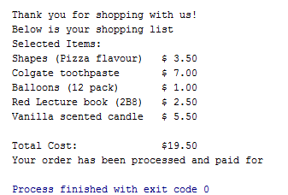

Figure : Pay for 5 items

## Test 3: Input “x” when prompted for an option at clear/pay prompt.

In this case, the system should warn the user that an invalid was entered. The system should also give the user a chance to enter a valid option after entering an invalid value.

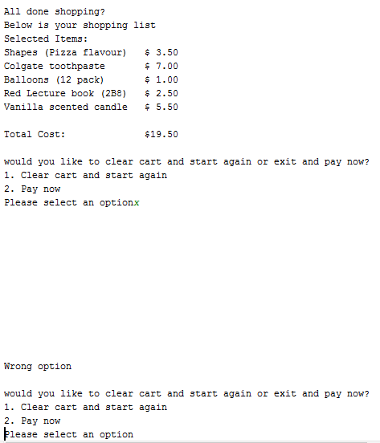

Figure : entering an invalid output

As can be seen on screenshots, the enhanced system performs as expected.